Online Test Application

# Developer name: Resapu Sai Tejaswini

# Technologies that were used in the project are:

* HTML
* CSS
* JavaScript

# Application features:

# View questionaries

# Display result

# Start-over

# Point calculation

# Displaying the incorrection option.

# Displaying the correct option.

This project has list 5 question which are static and will be random every time, each question will have four options, when user selects the correct answer it will be highlighted as green otherwise it will be highlighted as red. After answering each question user given options to move forward and results. User can skip to results without answering all the questions if a user tries to move to result without any answering all the questions then an alert will be thrown by clicking on OK user will be redirected to results page, after successfully answering all the questions the points of the user will be displayed. After that user will be provided with options such as show solutions and start-over. Show solutions options shows the answers for the questionaries and start-over will start the quiz all over again.

Home page:

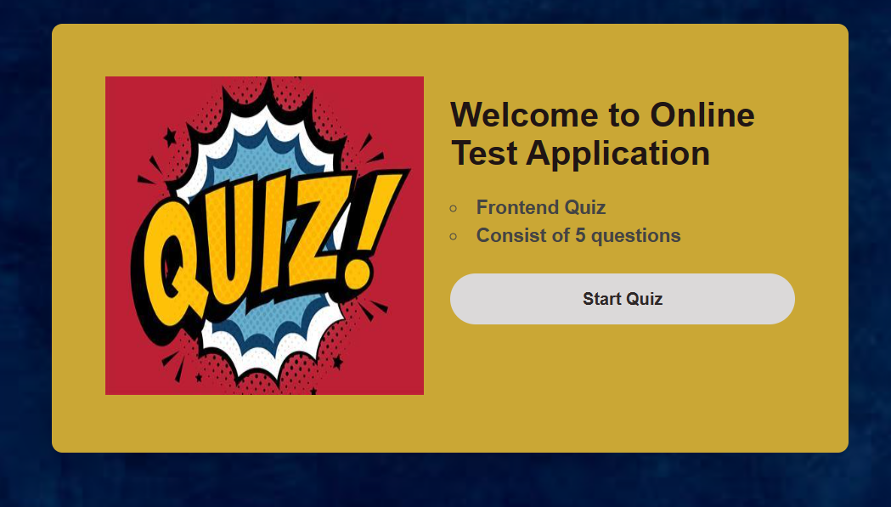

Questions of Quiz:

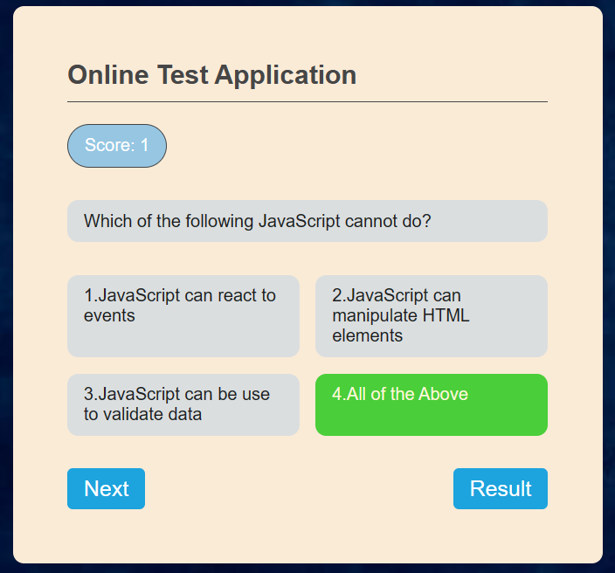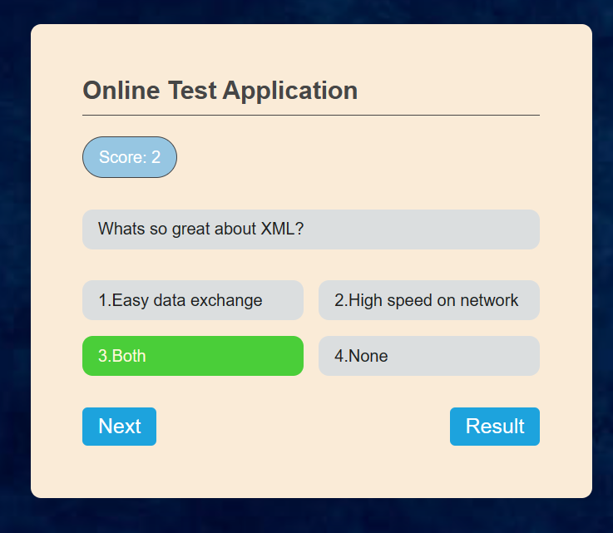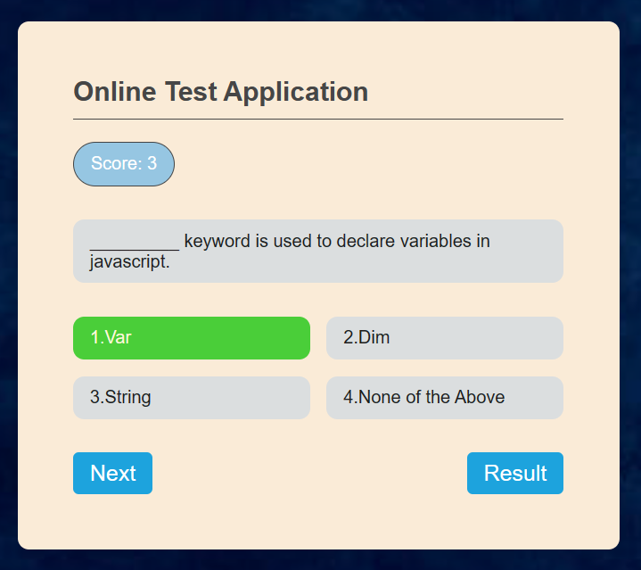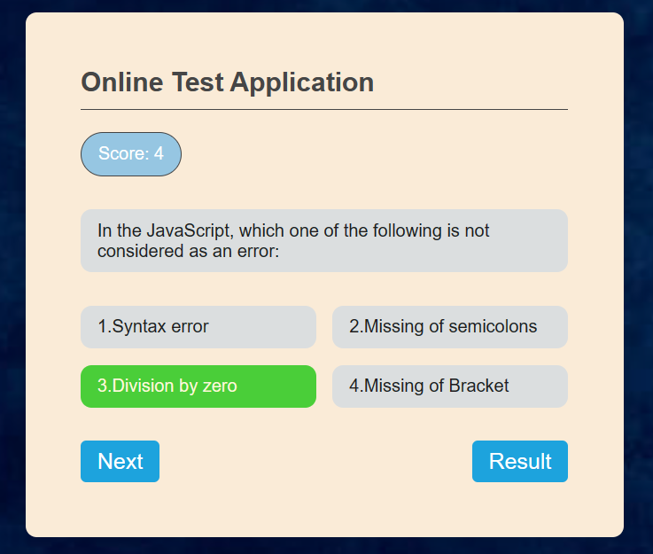

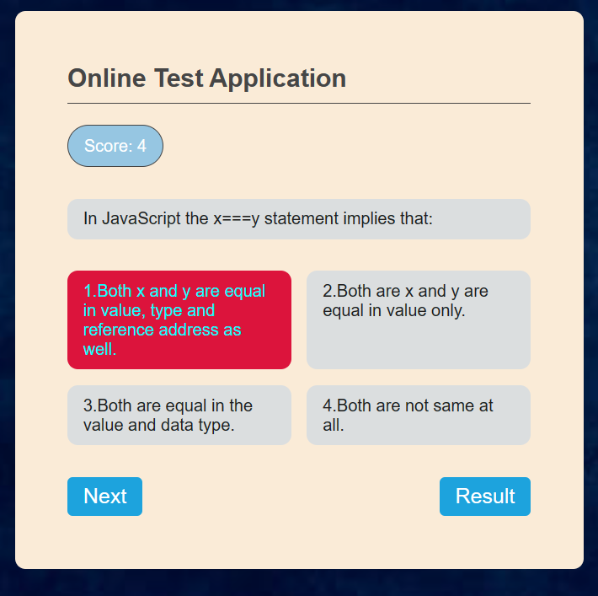

Quiz result:

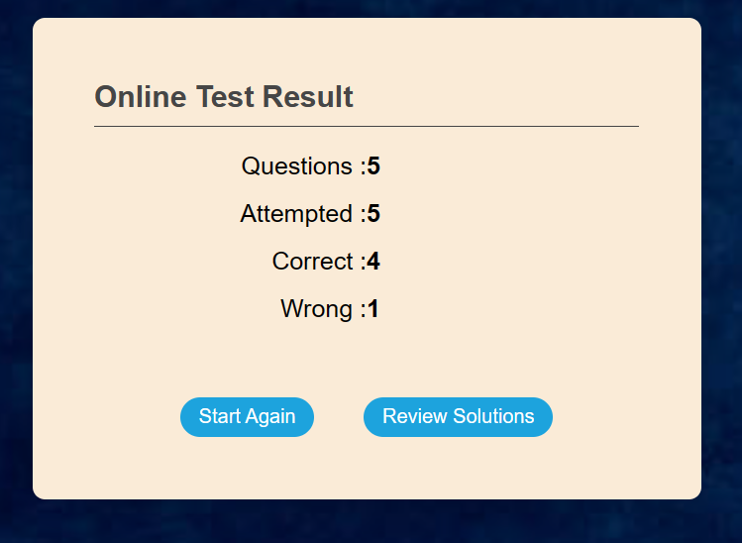

Solutions for the questions.

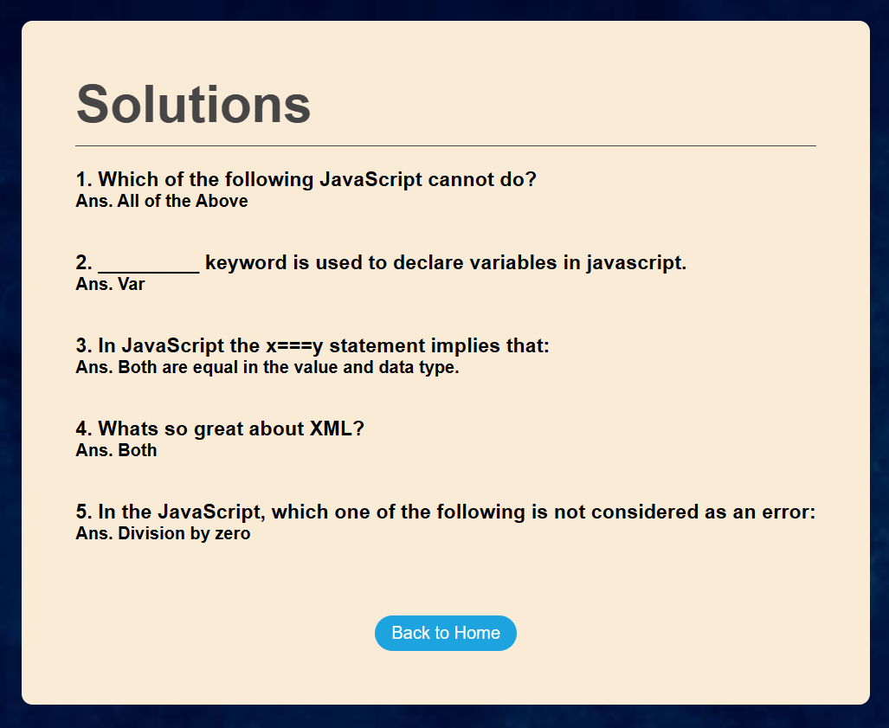

Alert message:

